Service Dogs Lead the Way at Southern
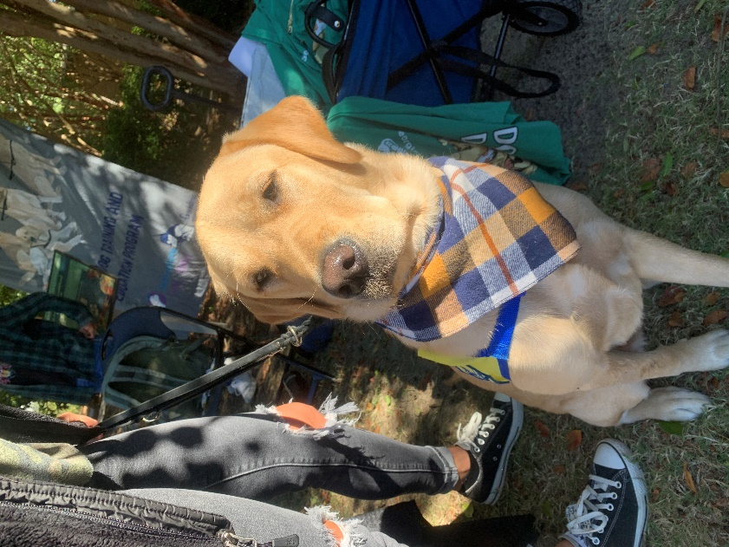
The Service dog Training and Education Program (STEP) at Georgia Southern is helping inform and make normal seeing man’s best friend on campus. The Club which has been at the University since 2013.

The club partners with 3 US- based organizations, Guiding Eyes for the Blind, Southeastern Guide Dogs and lastly, Canine Companions.

(Verano the Lab, A service dog with Canine companions)
Over the span of a three-year period the puppies are chosen even before they are born to be a helping hand to people with disabilities. After they are born, the puppies are raised in a non-profit volunteer’s home for about 8 weeks, then they are placed with volunteer puppy raisers. This part of the dog’s journey is where STEP comes in.

There the growing pup is taught basic commands such as stay, sit, and retrieve. Other tasks that the dogs are trained to do is become socialized with dogs and other animals.

“I am so happy that I have my support dog in my life.” Sarah Wright, who has had her dog for almost 9 months. STEP has 6 dogs that are currently being trained over the span of two years, after they finish basic training, they are then off to harness training in Orlando, Fl.

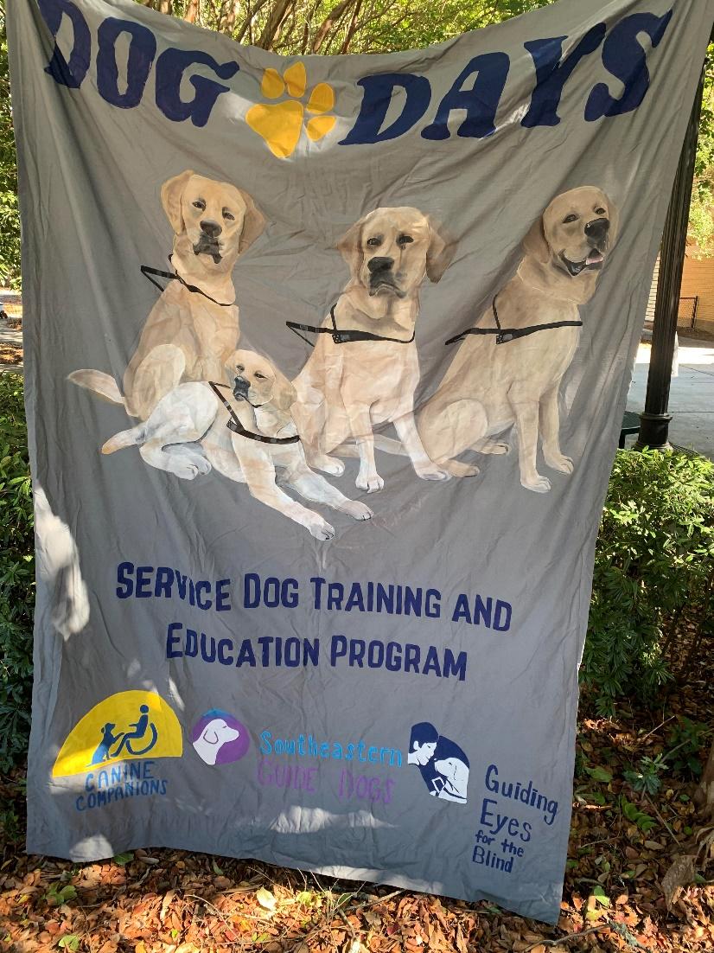
The STEP team works with Labrador Retrievers, Golden Retrievers, and Labrador mixes.

There are currently 30 members of the STEP program with each team assigned to help train these loving and helpful dogs to make a difference in someone’s life.

As an outreach, the club does multiple events such as a kisses for K9’s, hot dog fundraisers, giveaways, and dog days week. Sanijah Graham, a sophomore who has an emotional support dog named Latte, said that “Latte has helped me become more social rather than shutting myself off from the world, he has also helped me feel loved because my family is so far away from Statesboro.”

With the money that has been raised, the club takes the dogs that are in their care and takes them around the Statesboro campus and educates the college community about the importance and laws surrounding service animals.
The club plans to keep the public informed and supplied with these companions for life.

